**INSTITUTO TECNOLOGICO Y DE ESTUDIOS SUPERIORES DE OCCIDENTE**

**Data Science Master Program**

**REPORT #1:**

**Problem statement, contextualization, and specific and general objectives**

**Directors:** Dr. Jorge Arturo Pardiñas Mir, Dr. Riemann Ruiz Cruz

**Presented by:** Eng. Adrian Ramos Perez

adrian.ramos@iteso.mx

March 22nd, 2022

CONTENT TABLE

I. Problem statement 3

II. Contextualization 4

1. Acoustic Effects on a reduced space 4

Single point vs multi-point 6

2. Mathematical model of the space acoustic effects of audio signal and how it can be treated 7

Signal in Discrete Time 8

System’s Impulse Response 8

Z-Transform and Complex Plane 9

System’s Transfer Function 9

Inverse Impulse Response of a System 10

Classic Approach 10

3. Previous works on the theme 10

Minimum Phase vs Mixed Phase 11

Single point and multi-point approaches 11

Room response and its perception 12

Invertibility of the Room Response 12

Non-linear techniques 12

Neural Networks 13

III. General objective 13

IV. Specific objectives 14

V. Bibliography 14

# Problem statement

In any enclosed environment or space, as a room, when we listen sounds, they got altered by the reproduction system and the space characteristics like its dimensions and the materials it is made of.

For example, when there is a conversation going on in a room, the signals of the voices are affected by nearby reflecting walls, as the sound travels in many directions and not only to the receiver, bouncing off the walls [1]. This room effect is emphasized when the room is empty, so the produced sounds are perceived as an echo or reverb.

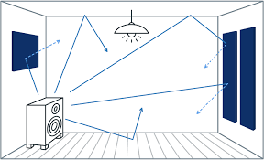

Figure 1. Sound paths reflecting on objects and walls in a small room.

This “room effect” can be undesirable depending on the application scenario, the dimensions of the room and the amount of the effect. One option to mitigate this is to design a system that performs the inverse effect of the room, a system that equalizes the room response to the sounds.

There are physical spaces that require special acoustic treatment which usually is very complex and expensive to get a desired acoustic, which is the case of music production studios (in specific mastering and mixing rooms), meeting rooms, cinemas, etc. This work aims to obtain a digital processing solution that could be simpler and less expensive for these kinds of scenarios.

## Acoustic Effects on a reduced space

When an enclosed space or room is small, there are several conditions that affect sound propagation in it. The smaller the room, the more problems it will cause by early reflections [4]. When a sound is reproduced, sound waves propagate through air and more mediums available inside the enclosed space, causing it to interact with multiple phenomena.

The incident wave gets physically affected when it reaches enclosing surfaces. Physical phenomena that occur to the original wave are:

* Reflection
* Diffraction
* Refraction
* Diffusion
* Absorption
* Reverberation

These effects are visually synthesized in figure 2:

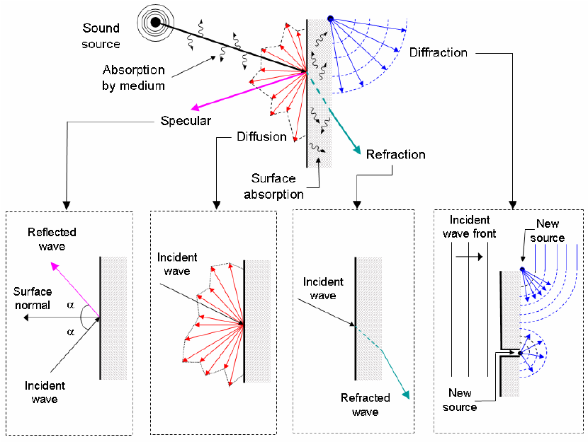

Figure 2. Reflection of waves on a wall.

Depending on the frequential content of a signal it will propagate in the room reaching different points depending directly on its wavelength. Lower frequencies have a longer wavelength comparing to middle and higher frequencies, and thus travel and reach far points from the point of emission.

From these effects, small rooms (approx. less than 42 m3) start having undesired acoustic properties and problems concerning sounds that are reproduced inside the enclosed environment.

A typical size and placement of an audio production control room is shown in figure 3.

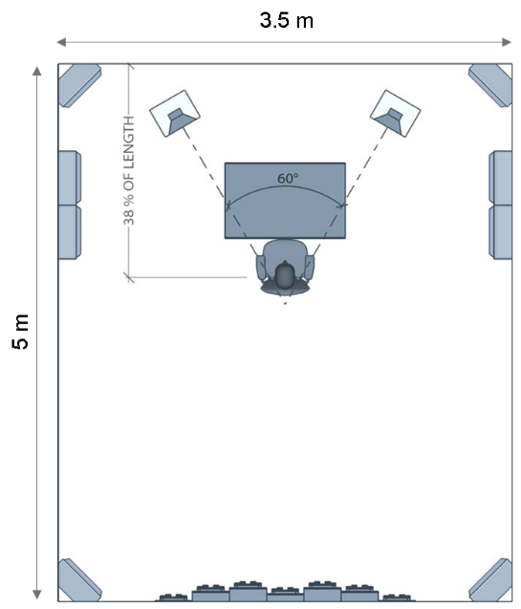

Figure 3. Audio production control room.

As said before, different sound frequencies are affected in different ways, in such a way that the effects are perceived differently in different points of the room. This mean that a solution that focuses on equalize a single point may not be valid for different positions and angles within the room, so here comes the multi-point approach where the focus relies in finding an average equalization for two or more points.

A way to look at the room effects over a sound signal, other than listening, is to analyze, for example, the energy modifications produced at different frequencies of the sound. Figure 4a shows a piece of an original voice signal in time domain, sound level variations over time, while figure 4b indicates the frequencies energy variations over time, spectrogram. Here, the darker the signal, the more intense it is. For example, at time 1.5 seconds, there is more energy at high frequencies than in low frequencies. Figure 4c shows the time signal after being affected by the room, as well as its spectrogram in figure 4d, where it can be observed the way in which the energy has changed over time.

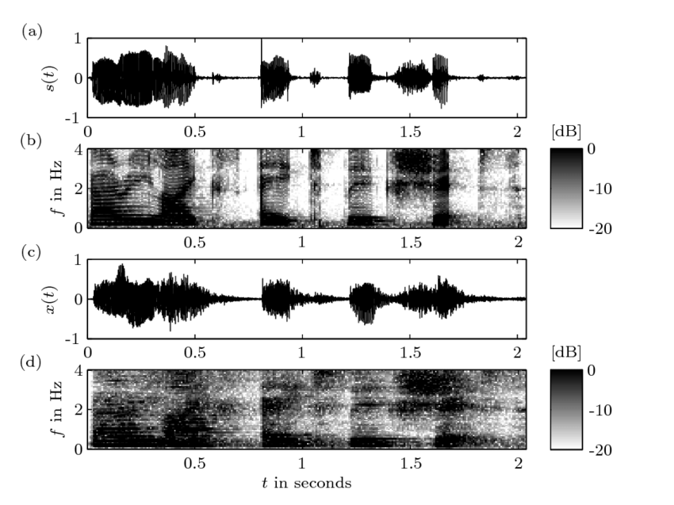

Figure 4. Room Response on a Speech Signal. a) original signal, c) signal after convolution with a room impulse response.

## Mathematical model of the space acoustic effects over an audio signal

2.1 The audio production and reproduction chain.

As depicted in the Problem statement section, the aim of this work is to obtain a digital processing solution to mitigate room effects over an audio signal that could be simple and low costly. The choose of working with digital signals is based on the versatility of processing them, work than can be done in a computer for validating the solution. At the same time, nowadays audio production is done almost entirely digitally and so have been proposed different solutions to the room effects problem, so this is the compatible way of doing it.

Figure 5 shows, in a synthetized way, all the components involved in the audio production flow, including the room effects.



Figure 5. Audio production chain in a control room.

The signals coming from different sources, like microphones, instruments, players, etc., usually a mix of continuous time (analog) and digital signals, are feed into the audio interface who properly converts and adapts all these signals in the digital domain. The audio production equipment lets process the signals to deliver the final product according to the producer. The resulting signal is then acoustically delivered to the room.

It is in the final blocks of the chain that some undesirable effects could be added to the audio signal. For example, some frequency response issues can occur in the reproduction equipment, due to the amplifier, the speakers or both. Finally, the room affects to the signal in the way that has already been described.

In this section, some mathematical elements that let represents and analyze the problem and possible solutions are presented.

2.2 Discrete-time signals and systems.

Working with digital signals requires to remember the fundamentals of analog to digital conversion: an analog signal, with a frequency content of a maximum frequency, must be sampled at least twice this frequency to avoid distortion. The amplitude values of the samples are quantized with a limited number of bits. The resulting discrete-time signal is represented as and it’s defined only for integer values of n, as shown in figure

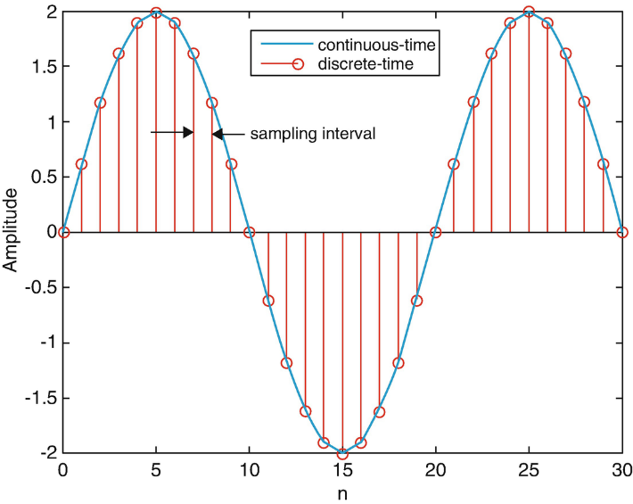

Figure 6. Representation of a discrete-time signal.

From the discrete-time signals and systems theory, it is known that the response of a linear and invariant-time system to an input signal can be calculated through the convolution operation between the input and the system response to a unit impulse signal, named as , figure 7.

Figure 7. A lineal time-invariant digital system.

, the impulse response (IR) of the system, models the behavior of the system as well as the difference equation of the system specifies how the output is related to the input signal . For example, the following simple equations describes the - relation and the of the same system:

For the realization of a digital system, both the difference equation and the convolution operation can be used.

Here, we are modeling the room effects as a system with an impulse response that affects the input signal coming from the audio reproduction equipment to produce the output signal, the perceived signal with the hereinbefore mentioned echo and reverb effects.

2.3 The system’s transfer function.

One effective tool that helps to analyze lineal time-invariant systems is the z-transform, which is the equivalent of Laplace transform for the discrete-time.

Using the Z-transform, a discrete-time signal is converted to the complex frequency domain.

When the z-transform is applied over the impulse response of the system, the result is known as the system’s transfer function (TF) . This models, from a different mathematical perspective, every possible output for a system given all its possible inputs.

For the convolution, its **Z- transform** results in:

Where , and are the z-transforms of , and ; which means that the z-transform of a system’s output is the multiplication of the z-transform of its input by its system function.

According to this result, the system function can also be calculated as:

The system function is a general case that includes the so-called frequency response of a system or H(w). H(w) corresponds to the values of H(z) for all *z*= ejw, or, in other words, for all z values with a magnitude equal to 1:  |*z*|=1

The frequency response of the system describes how the system affects each frequency component of the input signal.

2.4 The inverse system’s transfer function.

In the case of the effects of a room over the audio signal propagated into it, such effects could be theoretically eliminated by applying and additional system into the chain which transfer function, , performs the inverse effects of the room, figure 8.

Figure 8. An inverse system to counteract the room effects.

Where is then:

According to the previous elements, our problem is pointed into finding that inverse transfer function , for applying it to the signal prior to its reproduction in the room, altering the sound perception once it has been modified and played. This is the classical approach to solve this problem.